**File Organizer**

Project Report



Submitted In Partial Fulfillment of the Requirements of

Computer Application

NATIONAL INSTITUTE OF TECHNOLOGY KARNATAKA

SURATHKAL, MANGALORE -575025

September 2016

SUBMITTED BY: SUBMITTED TO:

SEIBORLANG MARBANIANG (14CA66) Dr. ANAND R.

MCA 5th Semester

**Title: -** File Organizer

**Project Aims: -**

The aim of this application is that it organize files of similar types into a particular folder, for e.g. A jpeg or png files will be moved to the picture folder within your storage. The app will scan the whole storage area of the phone or specific folder provided by the user for picture, videos, document, music files once everything is done it will move all the files from different location in to one.

**Module 1**: Scan Phone Storage for JPEG, Mp3, Mp4, etc.

This is the first module that will be executed when scan button is click.

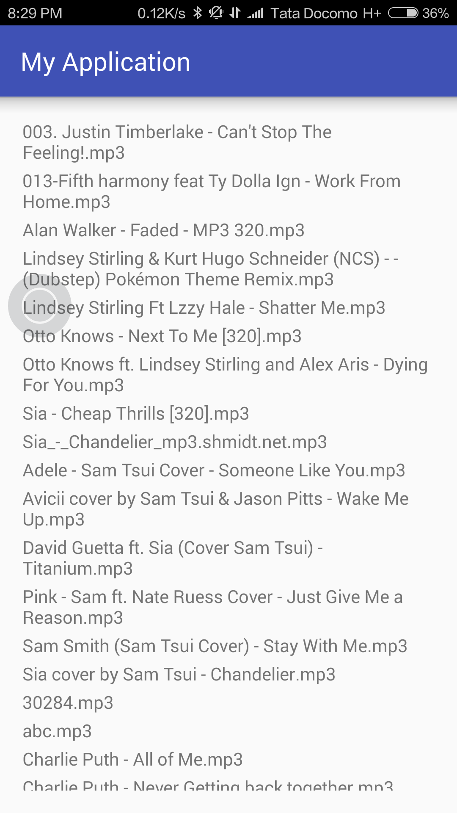

**Module 2**: Moving the files found

This module is still under development but it’s almost complete.

**Module 3**: UI

The UI is also under development.

**Conclusion:**

The main module are almost completed. Additional features will be added once the main module are running.